Exploratory Data Analysis: Ransomware and Misinformation Datasets

Stefanie Kenyon
Boston University
DX 699: AI for Leaders
Dr. Joshua Von Korff
June 28, 2026

1. Description of Project
This project analyzes two cybersecurity-adjacent datasets: a network traffic dataset capturing WannaLocker ransomware activity, and a text-based misinformation dataset containing labeled real and fake news articles. Together, these datasets represent two of the most pressing threats in the modern digital landscape—malicious software designed to encrypt and extort victims, and the spread of false information to manipulate public opinion.
The WannaLocker ransomware dataset was collected in August 2017 and consists of three CSV files concatenated into a single dataset of network flow records across dozens of features. WannaLocker is a mobile variant of the infamous WannaCry ransomware and was notably active in China targeting Android devices. The dataset was generated using CICFlowMeter, a tool that captures bidirectional network flows and extracts statistical features such as packet lengths, inter-arrival times (IAT), byte counts, and TCP flag counts. The target label for all records is RANSOMWARE_WANNALOCKER, meaning this is a single-class dataset representing only malicious traffic.
The misinformation dataset is a large collection of news article records, each containing a title, body text, and a binary label indicating whether the article is real or fake. The dataset is intended to support the training of machine learning models that can distinguish real journalism from fabricated stories. This type of tool has significant potential impact in combating the spread of disinformation in political, public health, and national security contexts.
The potential impact of both projects is substantial. A model trained on the ransomware dataset could be incorporated into an intrusion detection system (IDS) or network monitoring tool to flag suspicious traffic in real time. A classifier trained on the misinformation dataset could power browser extensions, social media moderation pipelines, or newsroom verification tools. Both projects align with the growing organizational need to integrate artificial intelligence into security operations centers (SOCs) and information assurance workflows.

2. What You Learned from Exploratory Data Analysis

2.1 Preprocessing
Preprocessing revealed meaningful data quality differences between the two datasets, though both were ultimately found to be usable.
Ransomware Dataset. The ransomware dataset, formed by concatenating three separate CSV files, contained no missing values and no duplicate rows, making it unusually clean for a real-world network capture. Column names contained leading whitespace that required normalization. No rows were dropped during preprocessing, and the dataset was used in its entirety for analysis. The Label column contained only one value—RANSOMWARE_WANNALOCKER—indicating that this is a purely malicious traffic capture representing a single ransomware variant. While this is sufficient for characterizing WannaLocker’s network behavior in isolation, a richer and more generalizable model could be built by adding a second ransomware variant dataset. For example, incorporating network traffic from WannaCry, the desktop predecessor from which WannaLocker was derived, or from a distinct family such as Ryuk or Cerber, would introduce comparative class labels and allow a classifier to learn to distinguish not just ransomware from benign traffic, but also to identify which strain is present, which has operational value for incident response teams who need to prioritize containment strategies based on the malware family.
No categorical encoding was necessary, as the only categorical columns were either identifier fields or the label itself. The label was set to a constant value for correlation and pairplot analyses given its single-class nature.
Misinformation Dataset. The misinformation dataset was more complex from a preprocessing standpoint. The raw file contained many rows with three columns: title, text, and label. Missing values were present across all three columns, and there were also a substantial number of duplicate rows. After dropping rows with any null value and removing duplicates, the dataset was reduced to a clean set of records for analysis.
The label field was stored as a string-encoded integer and was mapped to descriptive categories for clarity. No one-hot encoding was applied, as the label is a binary target variable. The title and text columns are raw text, which is not directly encodable without NLP preprocessing such as TF-IDF vectorization or embedding. For the purposes of this EDA, derived numeric features were created from the text fields to enable quantitative analysis, including word counts and character counts for both the title and body text.
The misinformation dataset showed a near-balanced class distribution after cleaning, with real and fake articles each accounting for roughly half of the records. This near-even split is excellent for model training and means that accuracy is a meaningful metric without requiring resampling techniques or class-weighted loss functions. The ransomware dataset, by contrast, has only one class, so any downstream supervised model would need to be paired with a benign traffic dataset or a second ransomware variant.

2.2 Univariate Analysis

Univariate analysis was performed using histograms, KDE plots, violin plots, and bar charts across both datasets.
Ransomware Dataset. The ransomware dataset contains many numeric columns representing network flow statistics. Nearly all these features exhibited strong right skew, with distributions heavily concentrated near zero and long tails extending to very large values. For example, Flow Duration showed a large gap between its mean and median, a hallmark of right-skewed data. Forward packet counts similarly indicated that most flows involve very few packets. These distributions are consistent with what would be expected in ransomware traffic, which often involves many short bursts of communication mixed with occasional large file transfers to command-and-control (C2) servers.
Flow Duration also as shown in Figure 1 exhibited extreme outliers visible in histograms, with a handful of flows lasting nearly the entire measurement window while the majority ended in under a second. Because the data was generated by a network traffic capture tool, these outliers are plausible rather than erroneous, but they are likely to distort any models that rely on raw feature values rather than log-transformed or normalized inputs. Bar plots of the Label column confirmed that all records belong to the WannaLocker class.
Figure 1
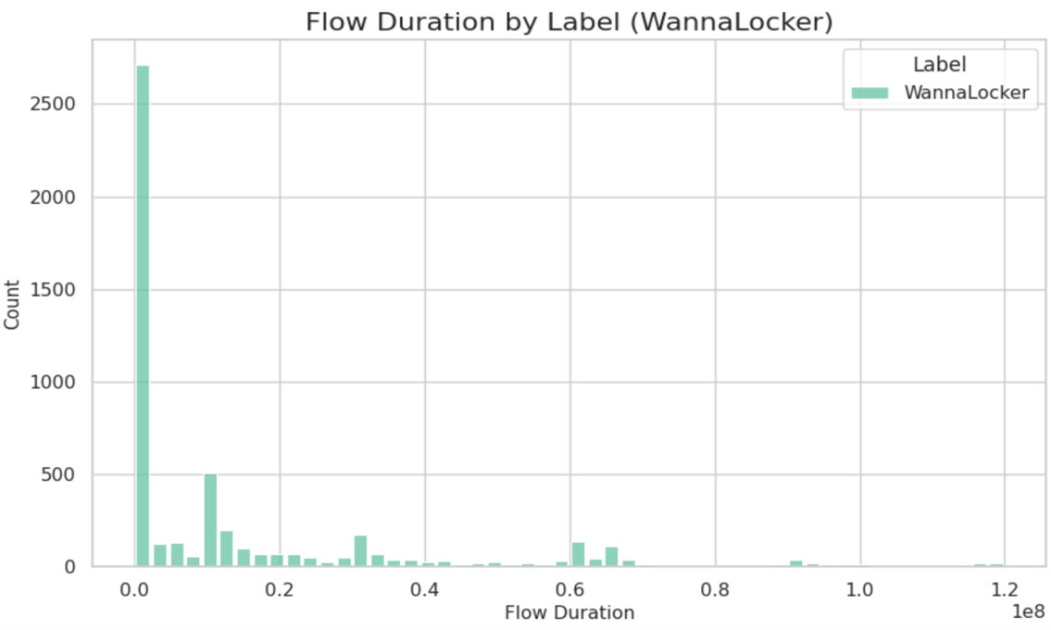
The protocol field had only a small number of unique values corresponding to common IP protocols, with TCP being the mode by a wide margin. This makes protocol nearly a constant for many records. Several flag-related columns appeared to be near-zero across the dataset, suggesting they may carry little predictive value.
Misinformation Dataset. Since the misinformation dataset contains only text columns, numeric features were derived for analysis. Title word counts showed a roughly symmetric distribution, suggesting that both real and fake articles tend to use similar-length headlines. Body text word counts were far more skewed, with a notable gap between the mean and median indicating that a subset of articles contained very long bodies that pulled the mean upward. Some articles extended to extremely high word counts.
Grouped histograms as shown in Figure 2 compares real versus fake articles on body word count revealed that fake articles tended to cluster at shorter text lengths, while real articles were more broadly distributed. This difference is potentially exploitable by a classifier. Bar plots of the label column confirmed a near-balanced class split after cleaning, which is ideal for model training. The mode of the text column was a single space, indicating many articles had minimal body content, which is consistent with the near-empty rows that were removed during preprocessing.
Figure 2
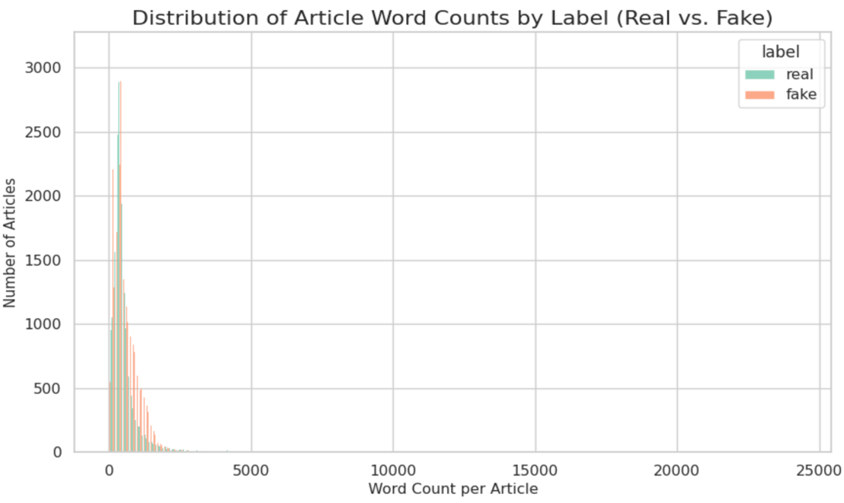

2.3 Bivariate Analysis
Bivariate analysis was conducted using correlation matrices, scatterplots, pairplots, and time-series line and area graphs.
Ransomware Dataset – Correlations. A correlation analysis of the numeric ransomware features identified many variable pairs with high absolute Pearson correlations. Several pairs achieved a perfect correlation, including subflow byte and packet counts paired with their corresponding total columns, average segment size columns paired with mean packet length columns, and duplicate header length columns. Figure 3 shows one of the pairs with a perfect correlation. These are clearly redundant features—pairs where one column is mathematically derived from or identical to another. Including both in a machine learning model would introduce multicollinearity and inflate the dimensionality of the feature space without adding predictive value. Dimensionality reduction through PCA or manual feature selection is strongly recommended for the WannaLocker ransomware dataset based on these correlations.
Figure 3
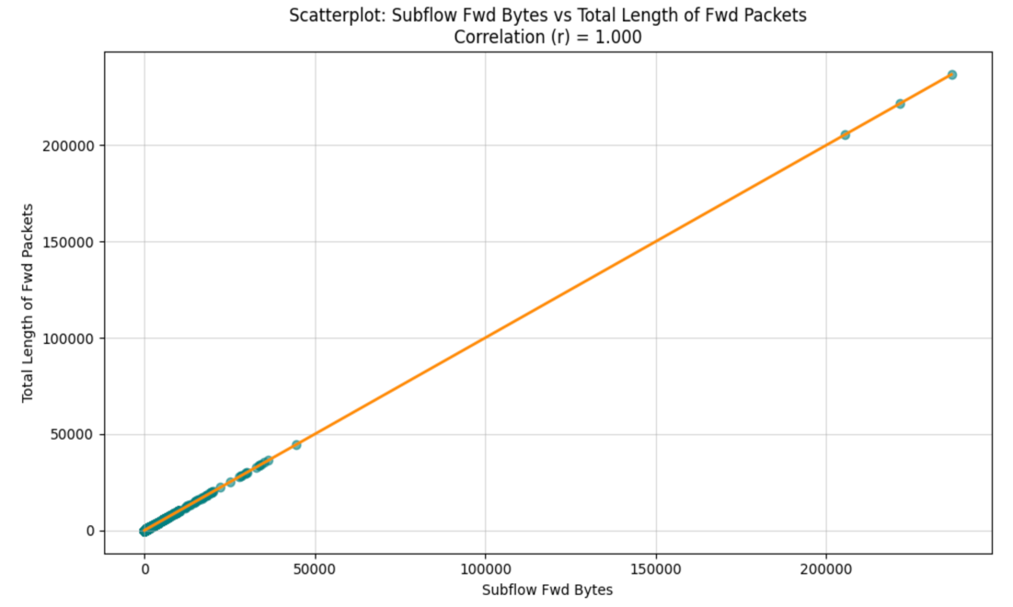
Ransomware Dataset – Time Series. A line graph of mean Flow Duration aggregated over time revealed an interesting pattern as shown in Figure 4: network flow durations were highly variable and chaotic early in the capture window, became smoother in the middle, and then grew chaotic again toward the end. This is consistent with ransomware behavior: the initial infection phase involves rapid, irregular communication with C2 servers as the malware establishes itself, while the encryption phase that follows may involve more regular, sustained file access patterns before the malware’s behavior becomes irregular again as it completes its payload. There does not appear to be a monotonic drift in the data over time, so temporal comparisons within the dataset remain valid.
Figure 4
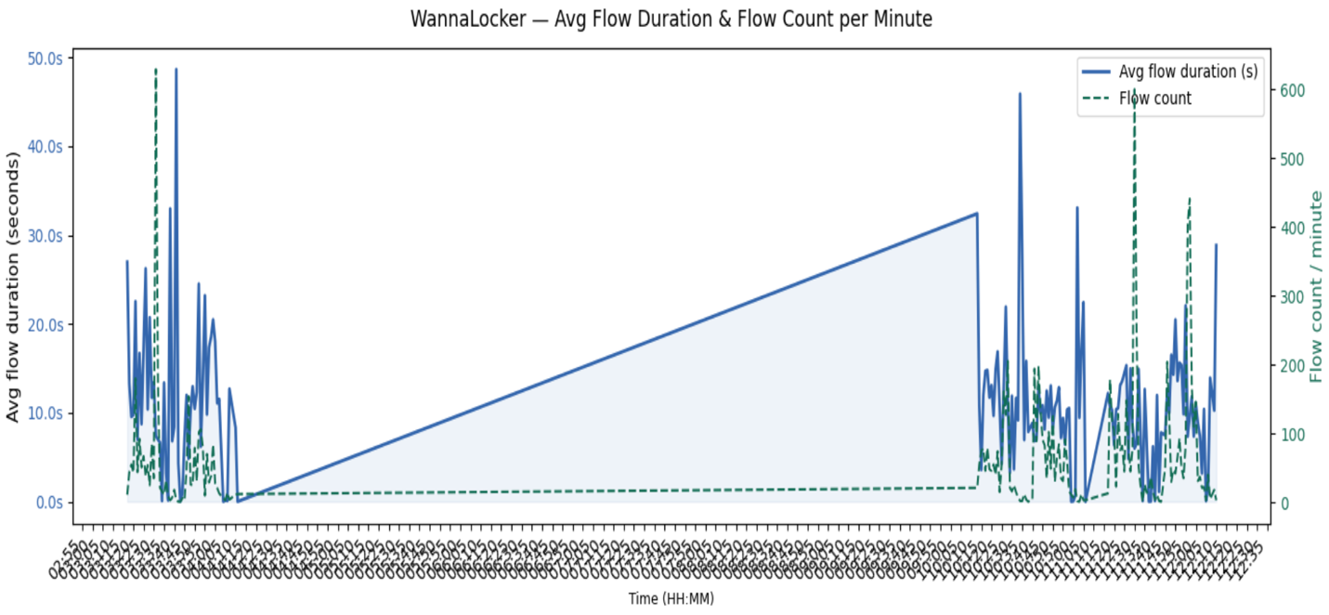
Ransomware Dataset – Outliers. Scatterplots for highly correlated pairs confirmed linear relationships but also revealed numerous outliers in the tails of flow duration, backward packet counts, and related features. Some flows had backward packet counts orders of magnitude higher than the majority, consistent with the right-skewed distributions identified in univariate analysis. A pairplot of selected key features highlighted that most data points cluster near the origin, with a small number of flows appearing as isolated points far from the main cluster. These extreme points are worth inspecting individually, though they may represent genuine edge cases in ransomware behavior such as large file uploads to exfiltrate encryption keys.
Ransomware Dataset – Confounding Variables. Several confounding variables could explain observed correlations. Source and Destination IP addresses are not included in the numeric feature set but are categorical identifiers that could explain clustering patterns. The test environment itself, involving a single infected device communicating with a small set of external servers, introduces network topology as a confounder: all traffic flows through the same gateway, which may inflate inter-arrival time correlation values. Time of day is another confounder, as ransomware communicating with C2 infrastructure may behave differently during off-hours versus peak usage periods.
Misinformation Dataset – Correlations. The correlation analysis of the derived numeric features revealed strong correlations within related pairs: body character count and body word count were highly correlated, as were title character count and title word count. Both are expected and nearly tautological—longer articles contain more characters and more words. These pairs are redundant, and including both in a model would likely produce little additional predictive benefit. Correlations between title features and body text features were near zero, indicating that title length and body length are essentially independent. This is consistent with journalistic practice: an article’s headline length is determined by editorial style and space constraints, not necessarily the length of the underlying story.
Misinformation Dataset – Scatterplots. Scatterplots where | r | > 0.8 were generated for the pairs with the highest correlations, both of which involved character count and word count for the same text field. Both showed tight linear relationships, confirming the redundancy of these pairs. Neither scatterplot revealed any particularly unusual outliers beyond the expected extreme-length articles. Figure 5 shows the correlation between text character count and text word count. No time-series analysis was possible for the misinformation dataset, as no date or timestamp fields were present.
Figure 5
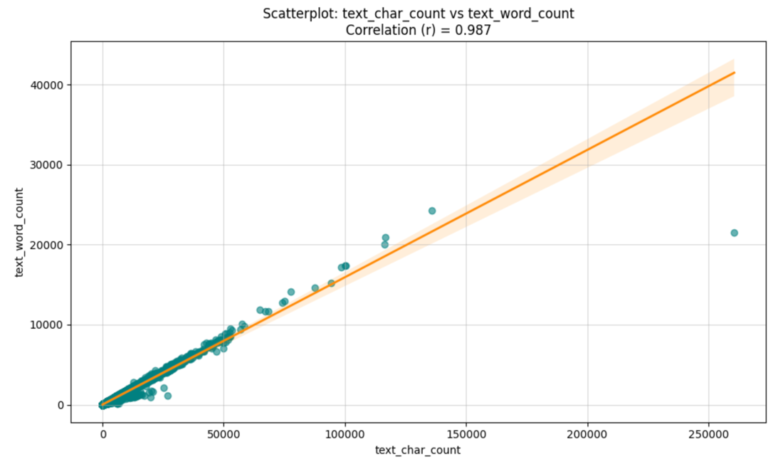
Misinformation Dataset – Confounding Variables. Several confounding variables are likely present in the misinformation dataset. Source and document type (e.g., news alert, opinion piece, investigative report, social media repost) could independently drive both label and text length, creating a spurious association between article length and veracity. Topic or subject matter (e.g., political policy requiring precise technical language versus celebrity gossip using short punchy sentences) could explain word count differences between real and fake articles. Publisher bias is another potential confounder: established news organizations with editorial standards may produce consistently longer, more detailed articles, while automated bot-generated fake content may be shorter and more formulaic. Finally, text scraping artifacts—such as HTML entities, special characters, and encoding errors as seen in Figure 6 (visible in some titles as sequences like "OBAMAâS")—could introduce systematic noise that a model might inadvertently learn to associate with one label.
Figure 6
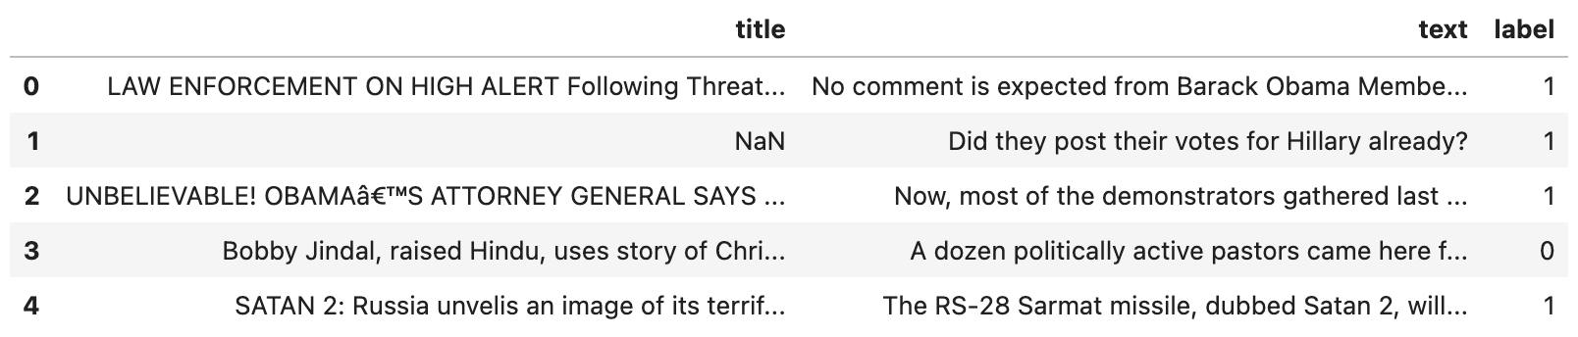

3. Conclusions

3.1 Expected/Unexpected Data

Expected findings. The right-skewed distributions of network flow statistics in the ransomware dataset were entirely expected. Network traffic is inherently bursty: most flows are short and involve few packets, while a small number of flows are long and involve many packets. The high degree of redundancy among flow features was also anticipated, as CICFlowMeter computes both aggregate totals and per-subflow breakdowns of the same underlying metrics. In the misinformation dataset, the near-balanced class distribution was a welcome finding, making the dataset well-suited for standard supervised classification without resampling.
Unexpected findings. Several findings were unexpected. First, the ransomware dataset’s single-class labeling was surprising in its uniformity. While the dataset was clearly described as a ransomware capture, the absence of any benign traffic means that it cannot be used alone to train a binary classifier that distinguishes malicious from normal traffic. A companion benign traffic dataset, or a second ransomware variant, would be required to introduce meaningful class contrast. Second, the presence of many duplicate rows in the misinformation dataset, many of which had no title, no text, or no label, indicated that the dataset had been poorly deduplicated before distribution. This is a meaningful data quality issue for any downstream modeling effort.

3.2 Disqualified Data
Neither dataset was entirely disqualified, but both required meaningful intervention.
For the ransomware dataset, the single-class nature of the dataset is not sufficient grounds for disqualification, but it does limit its standalone utility for multi-class or binary classification. As noted in Section 3.1, adding a second ransomware variant dataset such as WannaCry or Ryuk would address this limitation without requiring any disqualification of the existing records.
For the misinformation dataset, a meaningful portion of rows were removed during cleaning due to null values in one or more columns. Rows with missing labels were particularly problematic, as they cannot be used in any supervised learning task. Rows with missing titles or body text could theoretically be imputed but given the text-heavy nature of the classification task, an article with no body text provides almost no usable features. The cleaned dataset retains many records that is still more than sufficient for robust model training and evaluation.

3.3 Suggested Supervised/Unsupervised Analyses
Supervised analyses. For the misinformation dataset, the most natural approach is binary text classification. A logistic regression model trained on TF-IDF features from the title and text fields would serve as a strong, interpretable baseline. A gradient boosting classifier (such as XGBoost or LightGBM) applied to the same TF-IDF features, or to more sophisticated embeddings from a pretrained language model (e.g., BERT), could improve accuracy and handle nonlinear feature interactions. Because the dataset is well-balanced, standard cross-entropy loss and accuracy metrics are appropriate. The derived numeric features (word count, character count) could supplement or provide an initial feature set before full NLP is applied.
For the ransomware dataset, supervised classification would require pairing this single-class dataset with a benign network traffic dataset. Once combined, a random forest or gradient boosting classifier trained on the network flow features would be appropriate, given the highly skewed and non-normal distributions that are better handled by tree-based methods than by linear models. Feature selection should be applied first to remove the redundant perfectly correlated pairs identified in bivariate analysis, which would also reduce training time. A neural network trained directly on the raw flow statistics could also be considered, though it would require normalization or log-transformation of the heavily skewed features.
Unsupervised analyses. For the ransomware dataset, k-means clustering or DBSCAN clustering applied to the numeric flow features could reveal natural subgroups within the WannaLocker traffic, potentially distinguishing the initial infection phase, the C2 communication phase, and the encryption phase without requiring labeled data. Given the high dimensionality of the feature space, principal component analysis (PCA) should be applied before clustering to reduce noise and computational cost. For the misinformation dataset, topic modeling using Latent Dirichlet Allocation (LDA) or Non-negative Matrix Factorization (NMF) on the body text could reveal thematic clusters among the articles, which might in turn correlate with the real/fake label or reveal which topics are most frequently targeted by disinformation campaigns.

Citations/Bibliography

Lashkari, A. H., A. Kadir, A. F., Taheri, L., & Ghorbani, A. A. (2018). Toward developing a systematic approach to generate benchmark Android malware datasets and classification. Proceedings of the 52nd IEEE International Carnahan Conference on Security Technology (ICCST). https://www.unb.ca/cic/datasets/andmal2017.html

Pawan Kumar Verma, Prateek Agrawal, & Radu Prodan. (2021). WELFake dataset for fake news detection in text data [Data set]. In IEEE Transactions on Computational Social Systems (0.1, Numbers doi: 10.1109/TCSS.2021.3068519, pp. 1–13). Zenodo. https://doi.org/10.5281/zenodo.4561253

AI Appendix
No AI was used.

